# **Employee Cafe**

* Type “npm run dev” command at the VS Code terminal to compile the code
* Open the browser and type the http request as “http://localhost:5173”

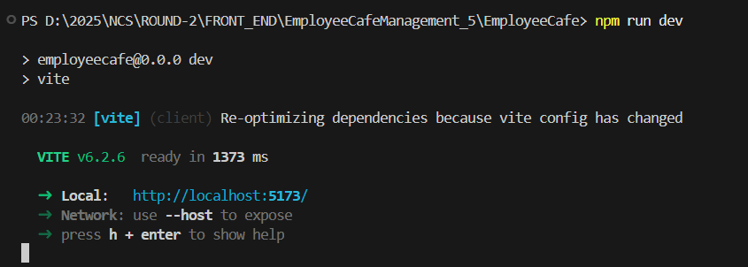

**Café Page:** When the Website is launched Café Page is displayed by default.

You can also click on the on the Menu bar to launch the Café page.

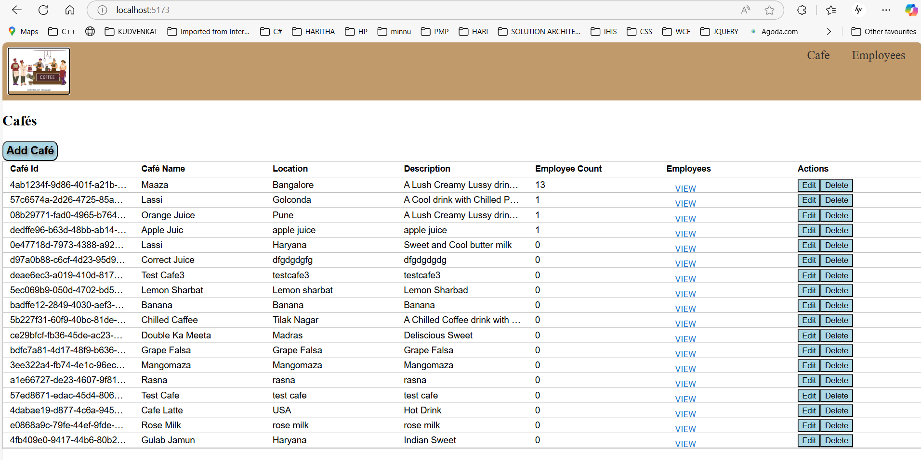

**Add Café:** Click the add button  to launch the Add Café page. Enter the Café details and click “Add” button to create new Café.

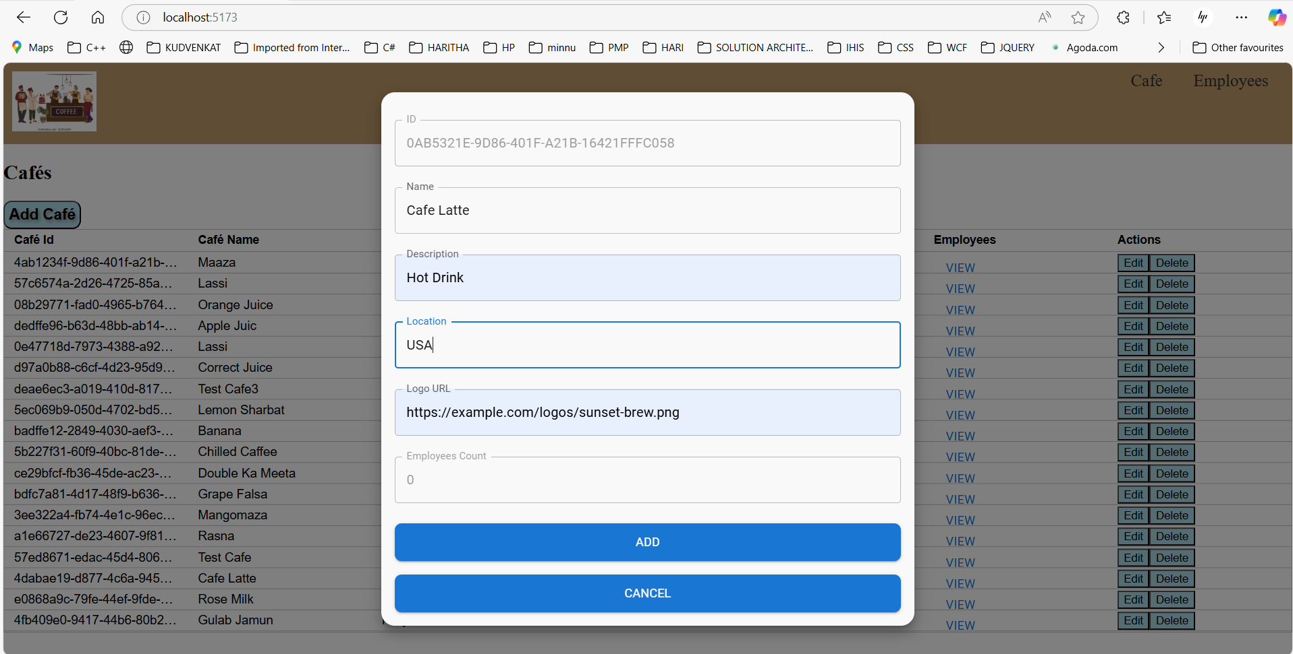

Café Latte is added as below

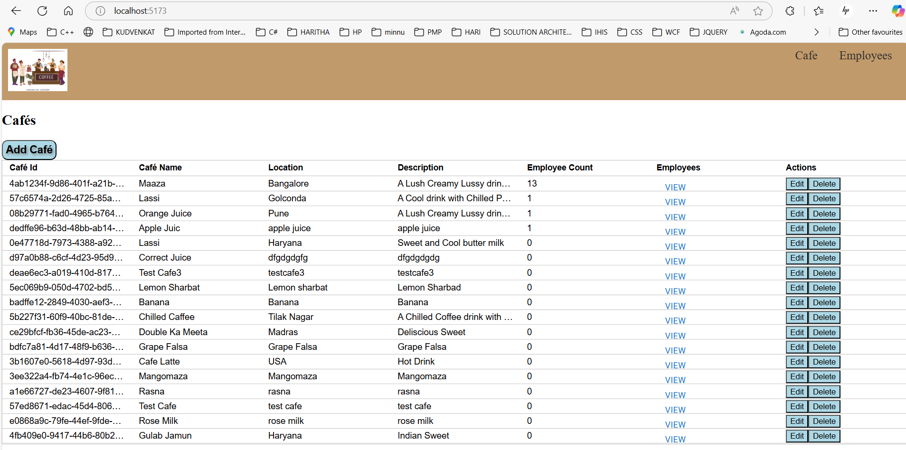



**Edit Café:** Click on the Edit button to open the Edit Dialogue. Update the details and click “Update” button.

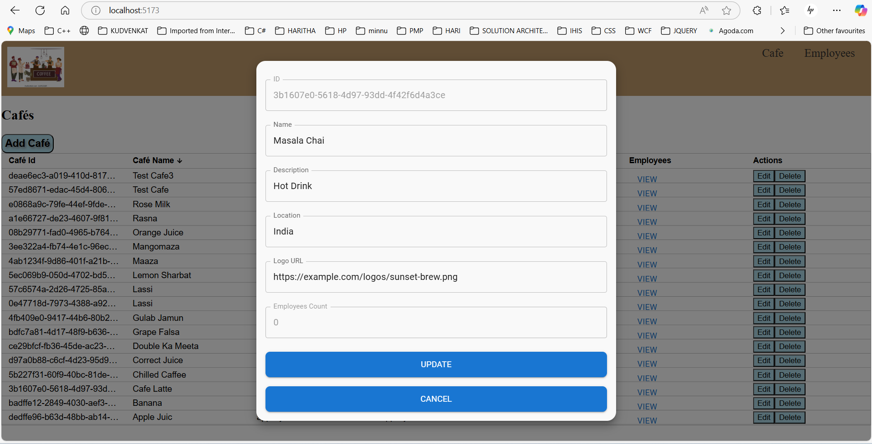

“Café Latte” is modified to “Masala Chai”

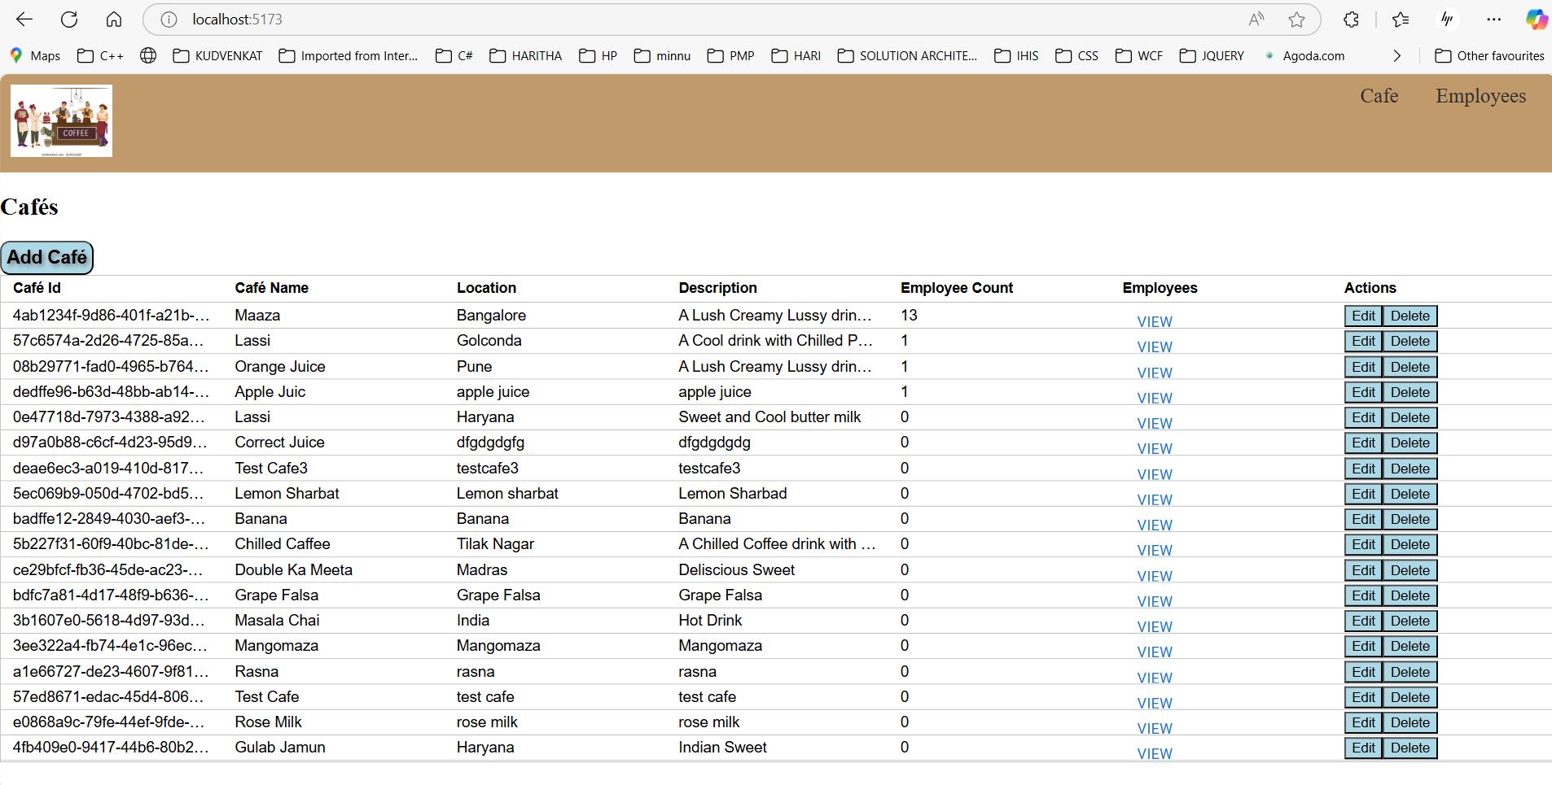

**Delete Café:** Click the Delete button to delete the selected record. Confirm Dialogue will be opened before deleting the record. To confirm delete the record, click on the “Delete” button

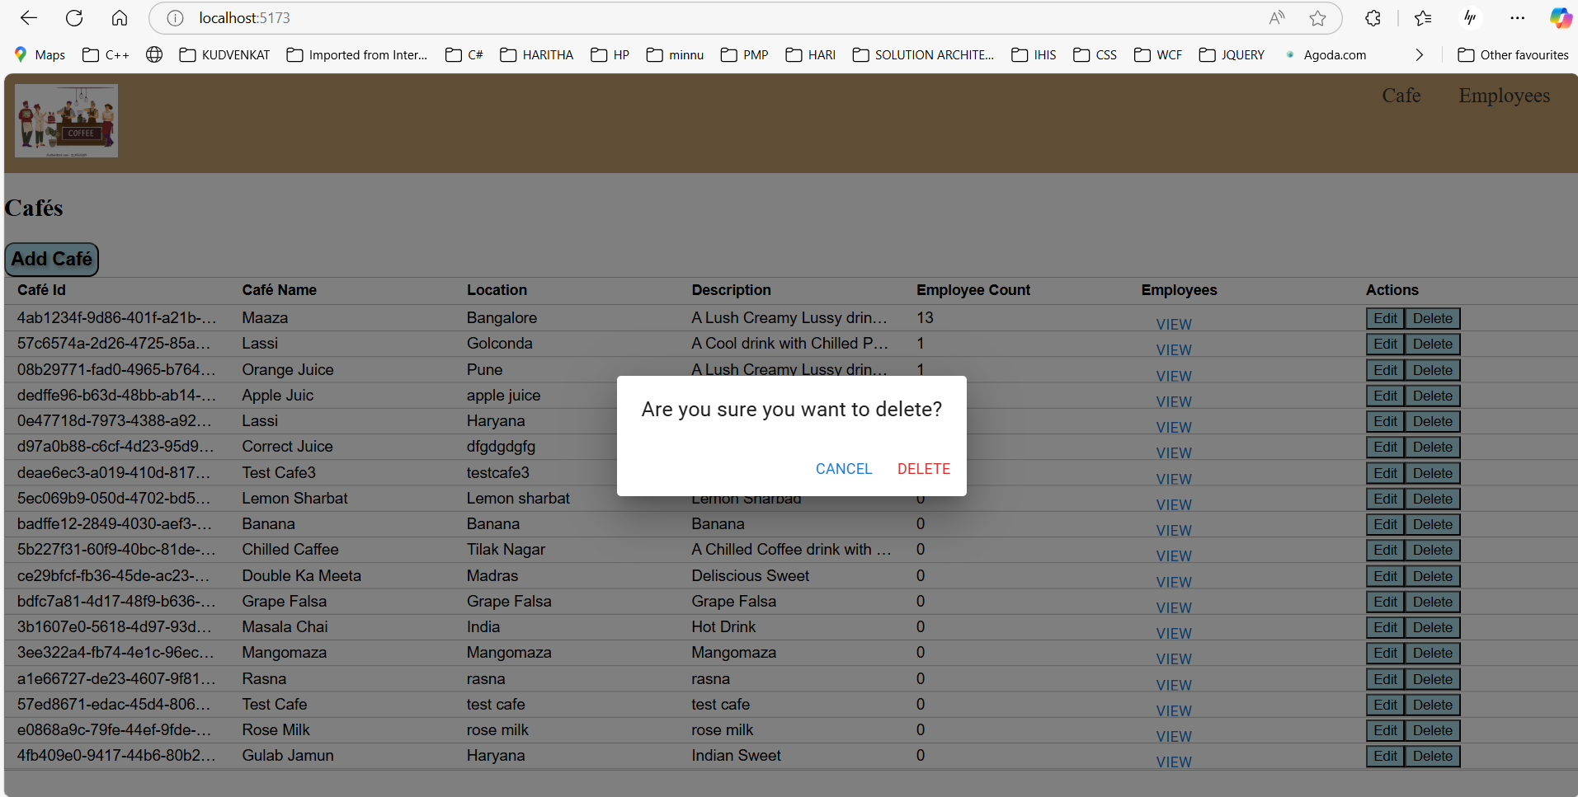

“Masala Chai” record is deleted

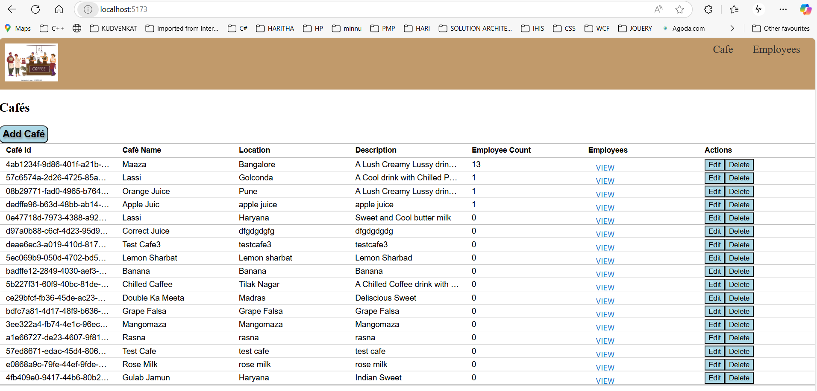



**View Employee from Café:** Click on the View Link to display the Employee details from the Café page.

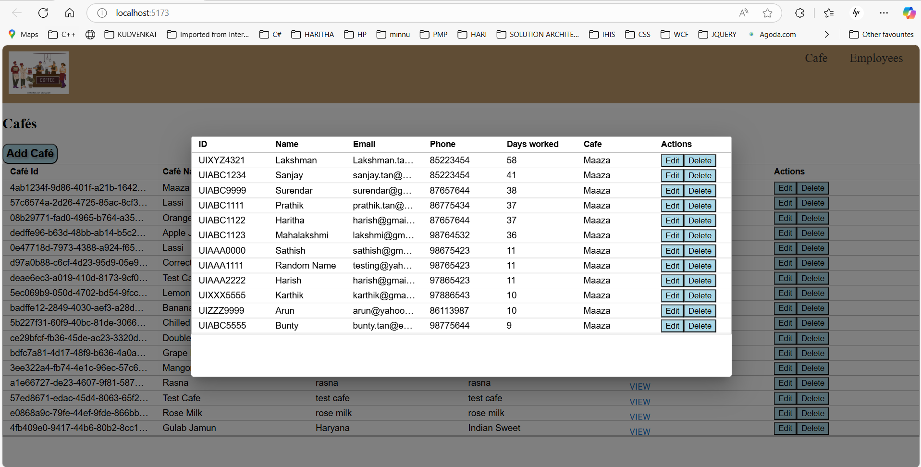



**EMPLOYEE Page:** Click on the Employee button on the menu bar to launch Employee page.

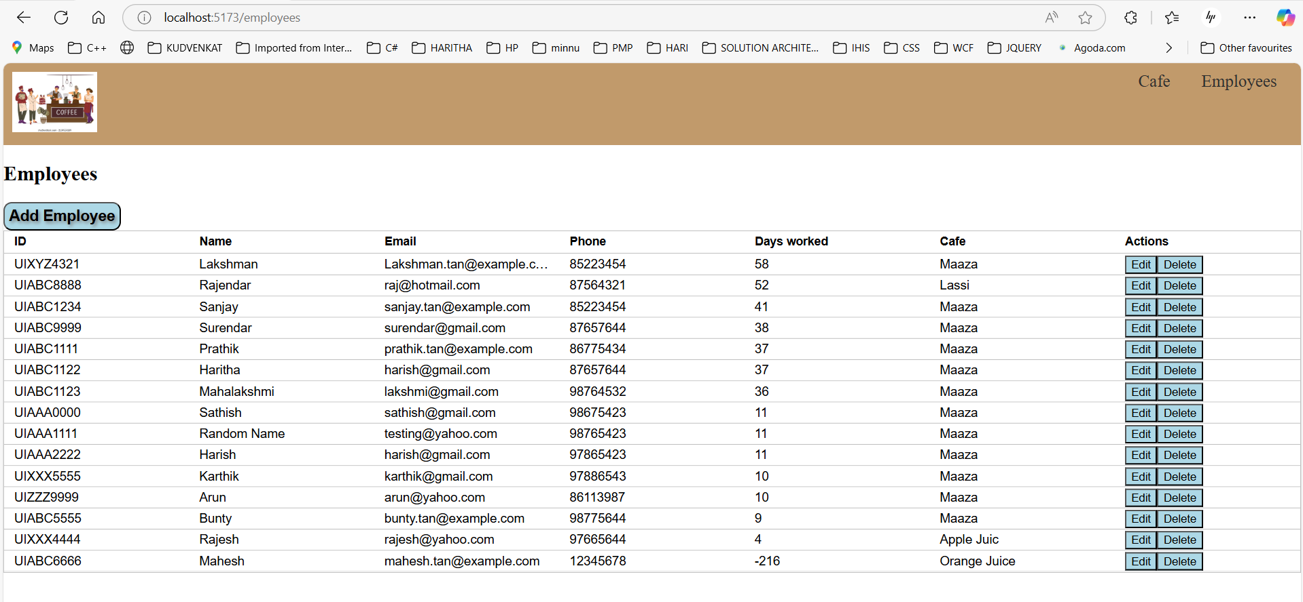

**Add Employee:** **:** Click the Add employee button to launch the Add Employee page. Enter the Employee details and click “Add” to create new Employee.

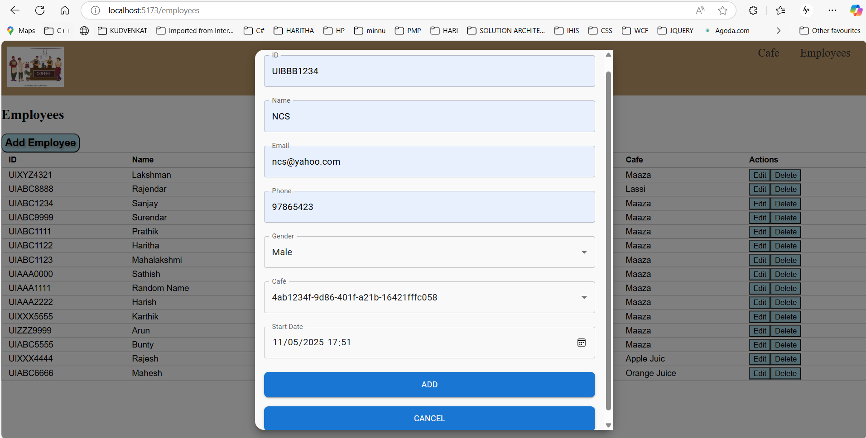

“NCS” record is added

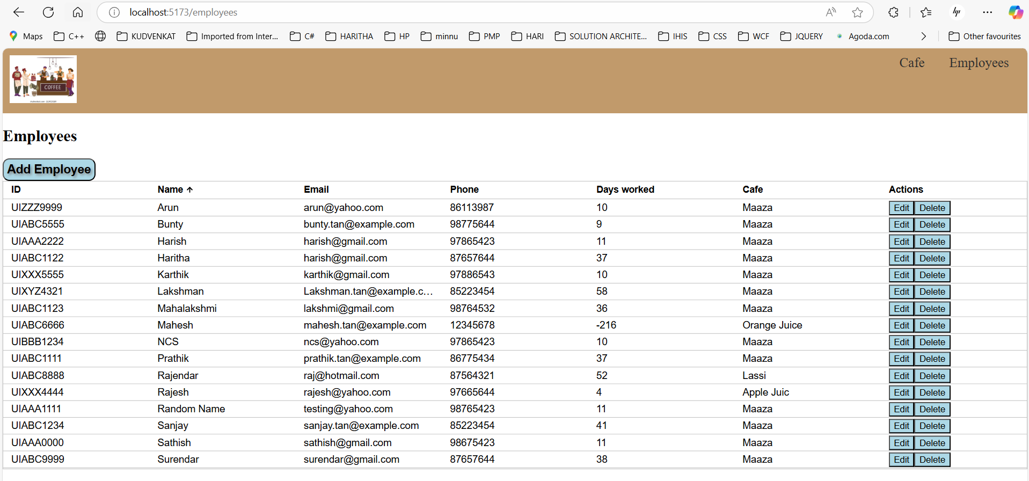

**Edit Employee:** **:** Click on the Edit button to open the Edit Dialogue. Update the details and click “Update” button.

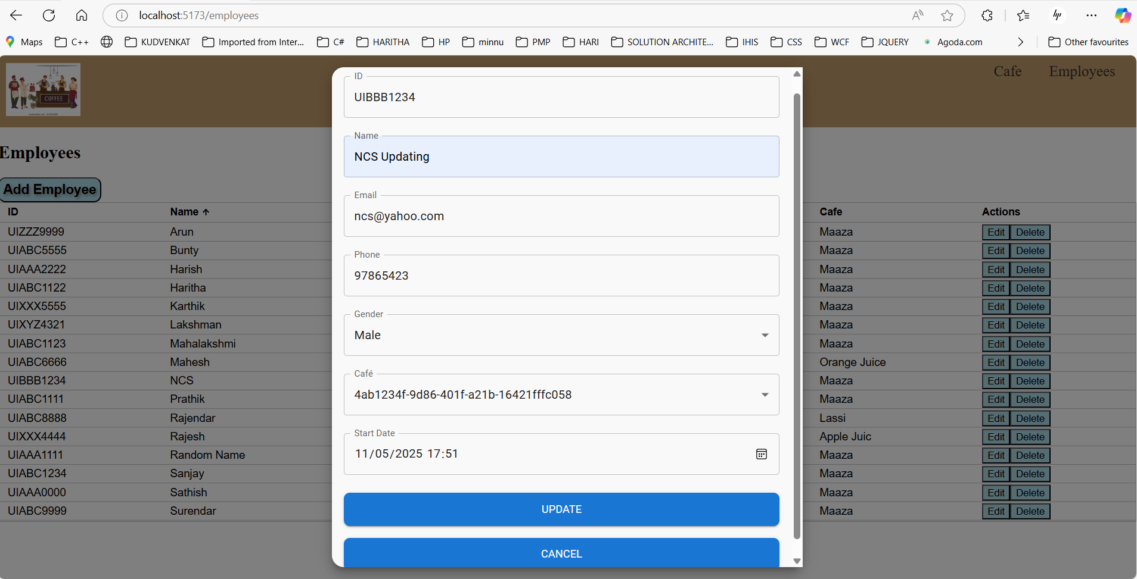

“NCS” record is updated to “NCS Updating”

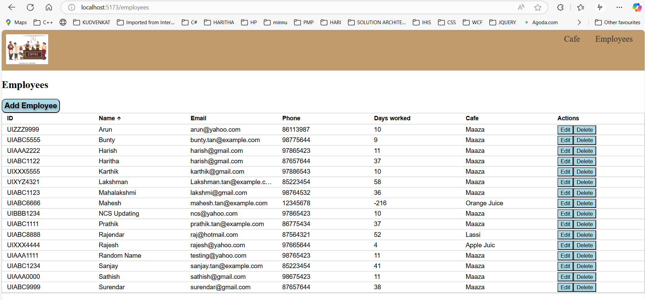

**Delete Employee:** Click the Delete button to delete the selected record. Confirm Dialogue will be opened before deleting the record. To confirm delete the record, click on the “Delete” button

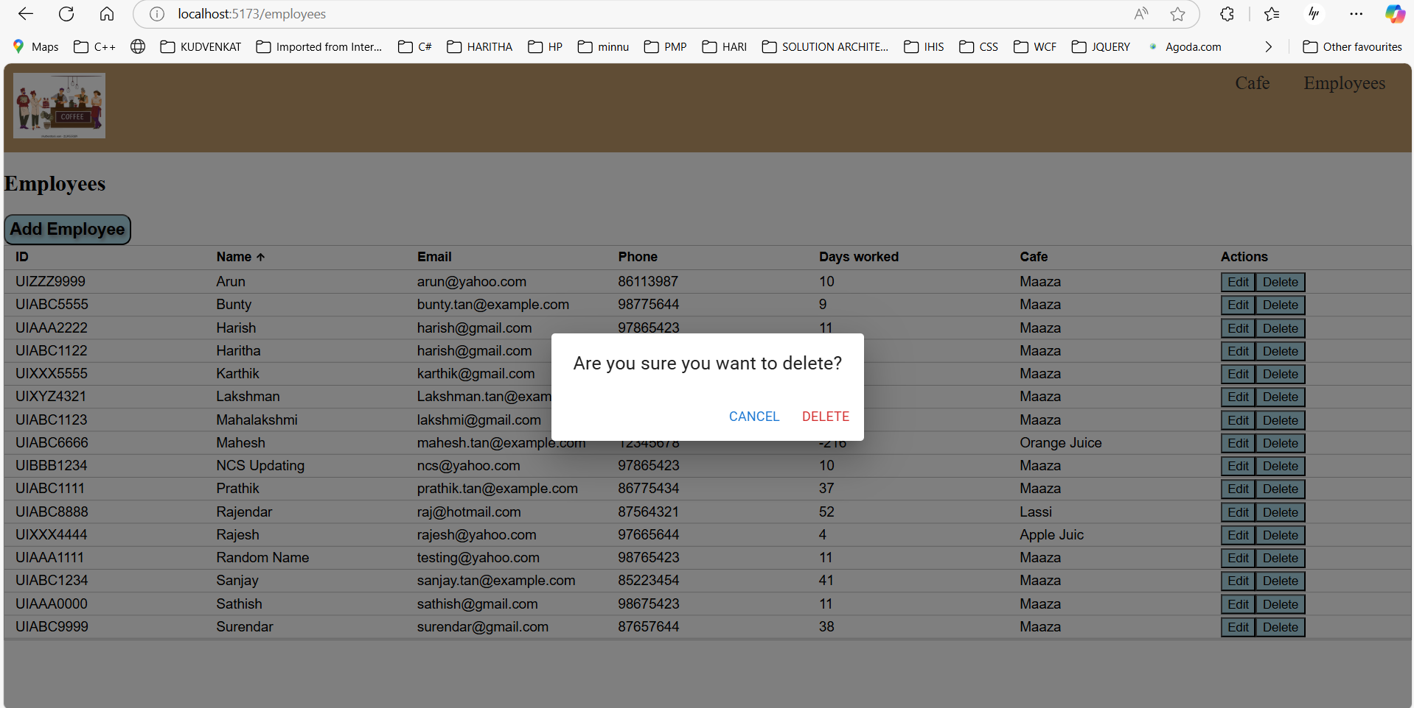

“NCS Updating” record is deleted

